**Topic Page No**

Abstract 3

Introductions 4

Methodology 5

**Scope and Objective 6**

Result 7

**Figures 9**

1. **Login page 9**
2. **Adding .cfs file 9**
3. **System Information 10**
4. **Media Files run in the suspects machine 11**
5. **Removable usb devices connected in suspects machine 12**
6. **Machines present in the same network used by suspect 12**
7. **Typed URLs in the internet explorer 13**
8. **Running processes in system 13**
9. **Automatic System Startups 14**

**10.** Applications installed in the suspects machine **14**

**References 15**

# 

# ABSTRACT

The development of technology has significantly increased the quantity of cybercrime incidents, which has made it much more difficult to combat it successfully. To combat cybercrime, a variety of cyber forensic methods and technologies are utilized to retrieve data from the devices. The current research paper focuses on memory forensic and analyses memory, which contains many pieces of information important to forensic investigation, such as username, password, cryptographic keys, deleted files, deleted logs, and running processes that can be useful to investigate the cyber-crime and identify the accused. Memory forensics involves three basic steps: gathering, examining, and recovering. With understanding of the various memory forensic tools and procedures, it may be able to recover criminal evidence from volatile memory.

**However, due to its limited lifespan, volatile memory is always difficult to analyze. The understanding of tools is crucial before applying to solve a specific cybercrime since not all tools can be utilized for memory forensic in every circumstance. Although it has not yet been determined if one tool can be utilized for a whole investigation, most of the techniques now in use are successful in producing credible evidence. The current study article offers information on how to analyze the memory that contains pertinent data, gather evidence from the devices, and extract crucial data using various memory forensic tools, tools beneficial for different reasons, and the appropriate tool for a given case.**

**INTRODUCTION**

**Memory forensics has gained prominence due to its ability to bridge the gap between post-incident analysis and the volatile nature of digital evidence. By capturing and analyzing the contents of a computer's RAM (Random Access Memory), practitioners can reconstruct a timeline of events, track intrusion vectors, and identify artifacts that might otherwise remain hidden in traditional disk-based analyses. This branch of forensics has proven indispensable not only in uncovering the intricacies of cyber incidents but also in attributing attacks to specific threat actors and understanding the methodologies they employ.**

**In this exploration of memory forensics, we delve into its fundamental methodologies and techniques. From the initial acquisition of a memory image to the intricate analysis of memory artifacts, we uncover the layers of insight that can be extracted from a digital environment's active memory. This investigation is not only a technical pursuit but also a testament to the collaborative effort between cybersecurity professionals, law enforcement, and legal experts. As the digital landscape continues to evolve, memory forensics remains an essential tool in the arsenal against cyber threats, offering a dynamic perspective on digital incidents and enabling proactive responses to safeguard sensitive information and critical systems.**

**Memory forensics involves analyzing a computer’s memory dump for forensic information. It is useful for investigating advanced computer attacks that do not leave traces on the hard drive. Memory forensics can reveal information such as malware processes, network connections, encryption keys, passwords, registry keys, and hidden files. This process involves extracting and examining the contents of a system's memory to gain insights into ongoing and past activities, identify running processes, uncover evidence of malicious behavior, and recover valuable information that may not be easily accessible through traditional file-based analysis. Memory forensics is especially relevant in cybersecurity investigations, incident response, and malware analysis.**

**Methodology**

**The methodology employed in memory forensics encompasses several steps, including memory acquisition, analysis, and interpretation. The process begins with the capture of the memory content from the target system, which can be achieved using various tools and techniques such as physical memory acquisition or memory dump analysis. Subsequently, the acquired memory image is analyzed to extract information such as active processes, loaded modules, registry data, and network connections. The interpretation of these artifacts provides insights into the system's state at the time of acquisition, aiding investigators in reconstructing events.**

**Win-LiFT Analyzer is a Windows Live Forensics Tool that is used for live forensics. It is used to acquire volatile data from a suspect’s machine and analyze the acquired data. Win-LiFT Analyzer is part of the Win-LiFT toolset, which also includes Win-LiFT ImagerBuilder and Win-LiFT Analyzer. Win-LiFT Analyzer is capable of analyzing the data collected by Win-LiFT Imager and creating a detailed report after analysis . It can analyze the live forensics data captured by Win-LiFT Imager from the suspect’s machine and perform advanced memory analysis from Windows XP and Windows 7 physical memory dump to extract forensically sound information. It can also perform structural analysis of reconstructed executables, registry analysis to retrieve forensically relevant information, event log analysis, browser verification forensics of acquired IE, Chrome information and Firefox bookmarking, keyword handling, searching multiple cases simultaneously, and displaying forensic evidence acquired in List/Tree/Summary View.**

**Scope and Objectives**

**Scope**

**Memory forensics is a vital subfield of digital forensics that involves the analysis of volatile memory data to extract valuable information about a system's state, processes, and activities. This project aims to delve into the intricacies of memory forensics, exploring its techniques, tools, and applications.**

**Understanding Memory Forensics Fundamentals: An exploration of the core concepts, theories, and principles behind memory forensics. This includes understanding the structure of volatile memory, how data is stored in RAM, and the significance of memory analysis in digital investigations.**

**Exploration of Memory Acquisition Techniques: A comprehensive overview of various methods for acquiring memory images from live systems, including both physical and virtual environments. This includes analyzing the advantages and limitations of techniques such as cold boot attacks, memory dump analysis, and using specialized tools for memory acquisition.**

**Investigation of Memory Analysis Tools: Research into a variety of memory analysis tools available within the digital forensics landscape. This involves the evaluation of open-source and commercial tools, understanding their functionalities, and comparing their features for different use cases.**

**Memory Artifacts and Evidentiary Value: Examination of the types of evidence that can be extracted from memory analysis, such as running processes, open network connections, encryption keys, and traces of malicious activities. Understanding the significance of these artifacts in establishing timelines and reconstructing digital incidents.**

**Malware Detection and Analysis: Exploring memory forensics' role in detecting, analyzing, and mitigating malware attacks. This includes understanding techniques to identify malicious processes, rootkits, and other forms of advanced threats that may hide within memory.**

**Real-World Case Studies: Studying real-world case studies where memory forensics played a critical role in solving complex cybercrime cases. Analyzing how memory analysis was conducted, the challenges faced, and the outcomes achieved.**

**Objectives:**

**The primary objectives of this project are as follows:**

**To Develop a Comprehensive Understanding: To gain an in-depth understanding of memory forensics principles, techniques, and methodologies, enabling effective utilization in digital investigations.**

**To Explore Memory Acquisition Techniques: To investigate and demonstrate various memory acquisition techniques, highlighting their advantages, limitations, and applicability in different scenarios.**

**To Evaluate Memory Analysis Tools: To assess and compare a selection of memory analysis tools, evaluating their capabilities, usability, and effectiveness for specific use cases.**

**To Analyze Memory Artifacts: To identify, document, and analyze key memory artifacts that hold evidentiary value, and to showcase their role in reconstructing digital events.**

**To Enhance Malware Detection Skills: To enhance skills in identifying and analyzing malware through memory analysis, contributing to improved cyber threat detection and response.**

**To Provide Practical Insights: To present practical insights through the examination of real-world case studies, demonstrating the significance of memory forensics in solving intricate digital cases.**

**Results**

**Memory forensics yields valuable outcomes that contribute to digital investigations, cybersecurity efforts. By analyzing a computer system's volatile memory, practitioners can uncover a range of critical information and insights, including:**

**Malware Detection and Analysis:**

**Memory forensics enables the identification of active and dormant malware in a compromised system. Analysis of memory artifacts can reveal malicious code injections, rootkits, and backdoors that traditional antivirus tools might miss.**

**Process Analysis:**

**Investigators can gain real-time visibility into running processes, their execution paths, associated metadata, and inter process communications. This helps in identifying suspicious or unauthorized activities.**

**Network Connections:**

**Active network connections, open ports, and communication patterns can be extracted from memory. This information aids in understanding the extent of a breach, identifying remote connections, and spotting anomalous network behavior.**

**Intrusion Detection and Attribution:**

**Memory forensics assists in reconstructing the timeline of an attack, providing insights into the initial intrusion vector, lateral movement, and data exfiltration. This aids in attributing actions to specific threat actors or groups.**

**Data and Artifact Recovery:**

**Sensitive data, credentials, encryption keys, and fragments of files can be recovered from memory. This can provide evidence of data theft, password usage, and other unauthorized access.**

**Anti-Forensics Detection:**

**Skilled attackers often deploy anti-forensic techniques to evade detection. Memory forensics can uncover evidence of such tactics, shedding light on attempts to hide or alter malicious activities.**

**Incident Reconstruction:**

**By analyzing memory artifacts alongside other sources of evidence, investigators can reconstruct the sequence of events during an incident. This aids in building a comprehensive narrative for reporting and legal purposes.**

**Enhanced Incident Response:**

**Memory forensics offers rapid insights into ongoing incidents, allowing for quicker mitigation and containment of threats. It assists incident response teams in making informed decisions to minimize damage.**

**Forensic Analysis:**

**Memory artifacts can be used to corroborate findings from disk-based forensics. Cross-referencing data from multiple sources enhances the overall accuracy of the investigation.**

**Proactive Security Measures:**

**Knowledge gained from memory forensics can be used to improve security measures, patch vulnerabilities, and implement countermeasures against specific attack techniques.**

**Figures**

1. 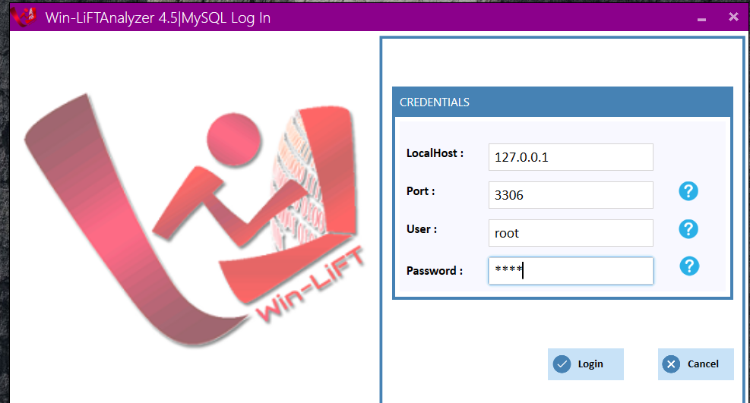**Log In Page:**
2. **Adding. cfs File:**

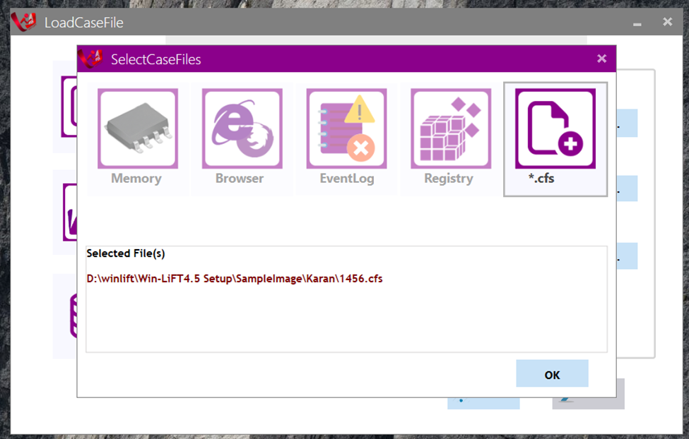

1. **After Adding .cfs file:**

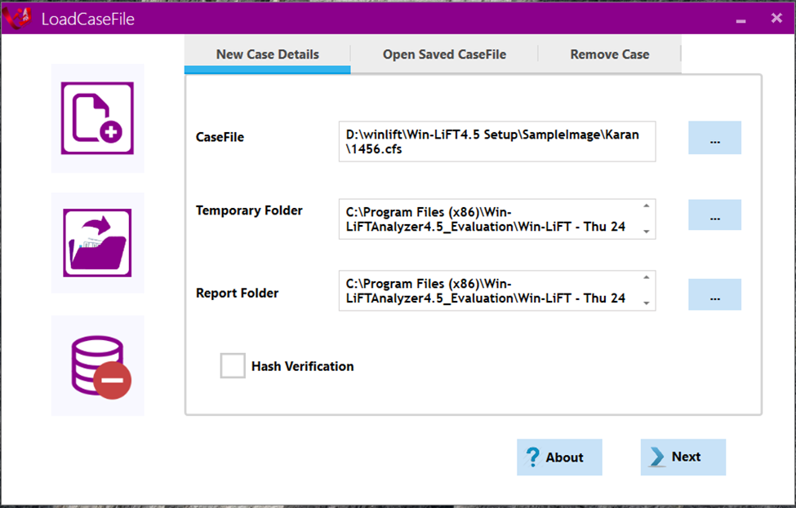

1. **System Information:**

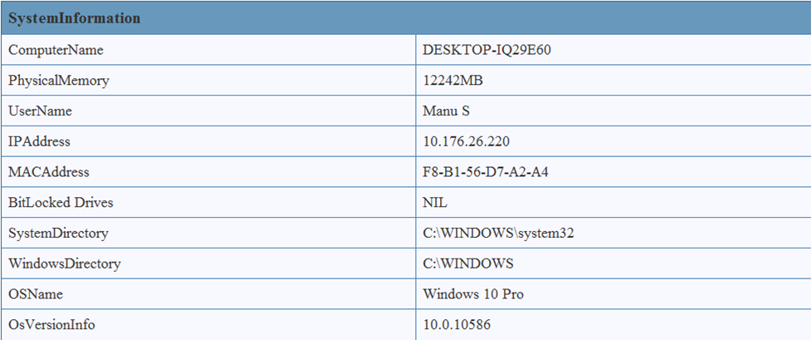

1. **Media Files run in the suspect’s machine:**

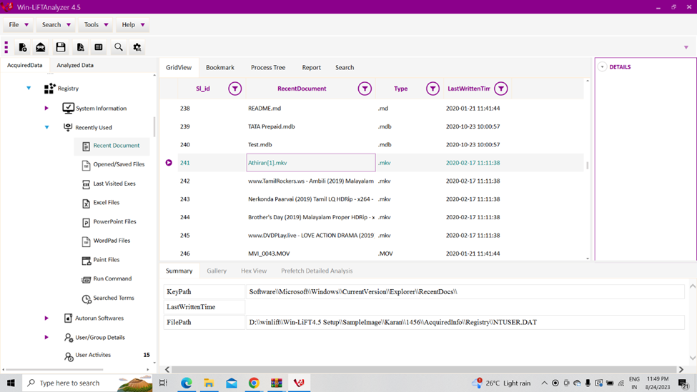

1. **Run commands used by the suspect machine:**

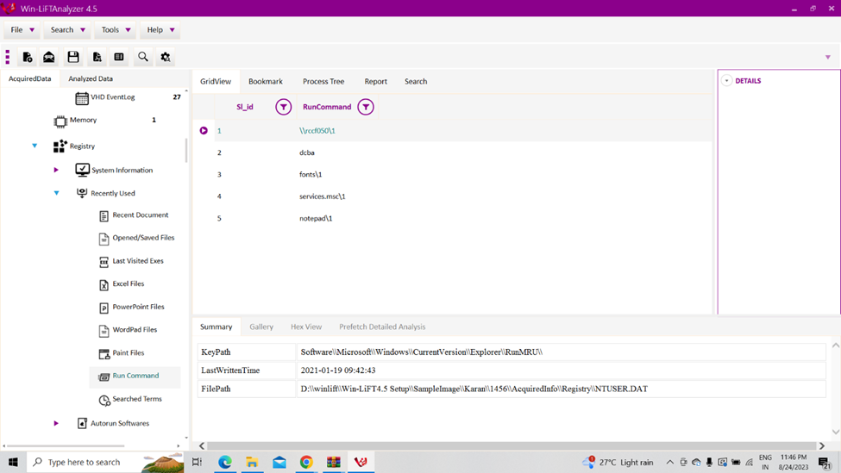

1. **Removable usb devices connected in suspect’s machine:**

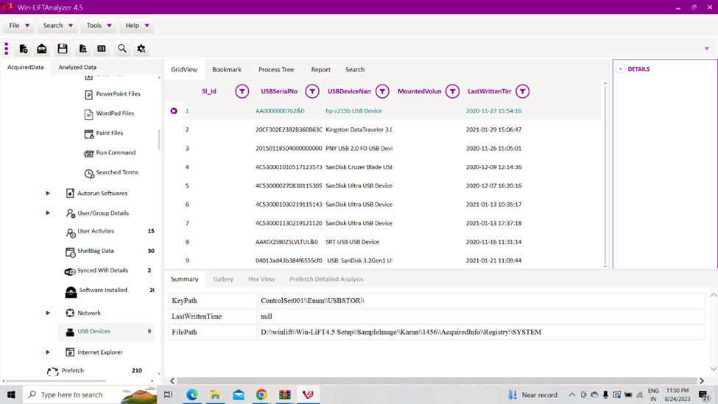

1. **Machines present in the same network used by suspect:**

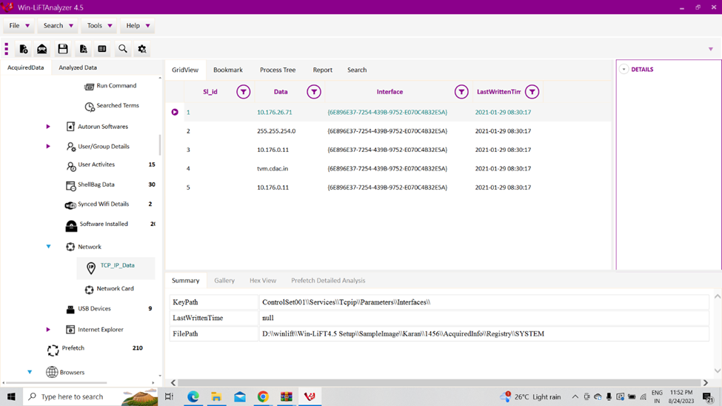

1. **Typed urls in the internet explorer:**

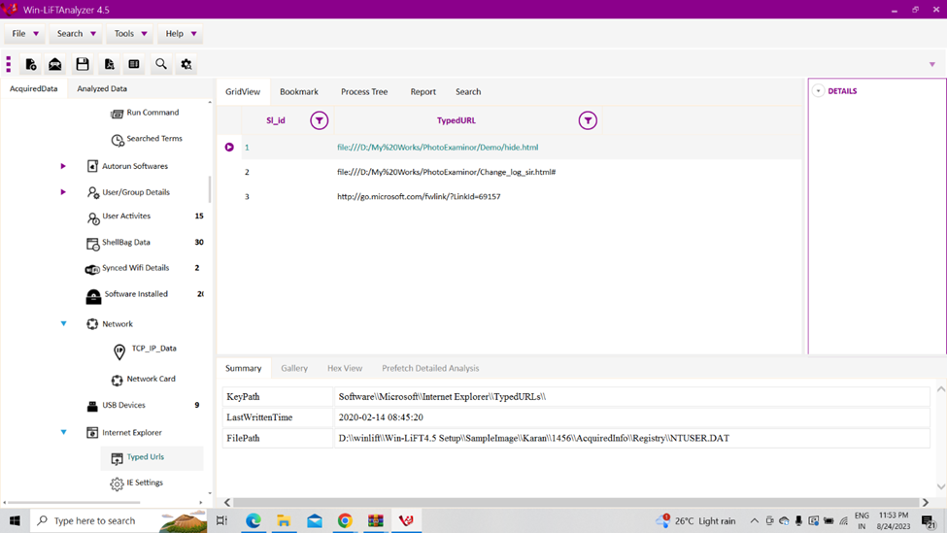

1. **Running processes in system:**

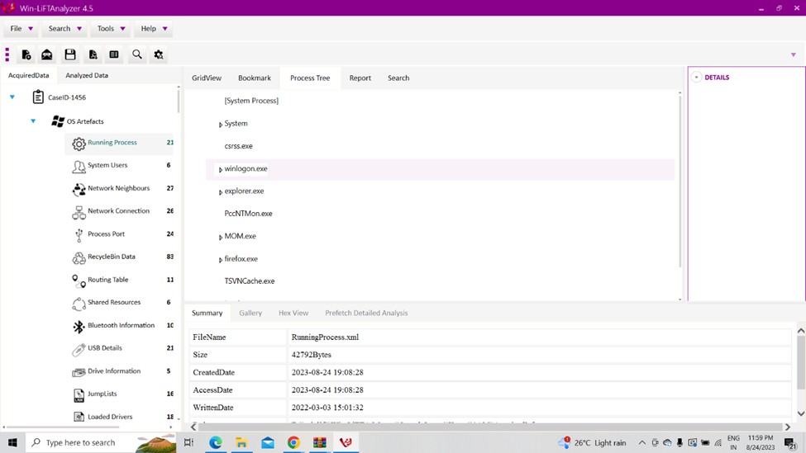

1. **Automatic System Startups:**

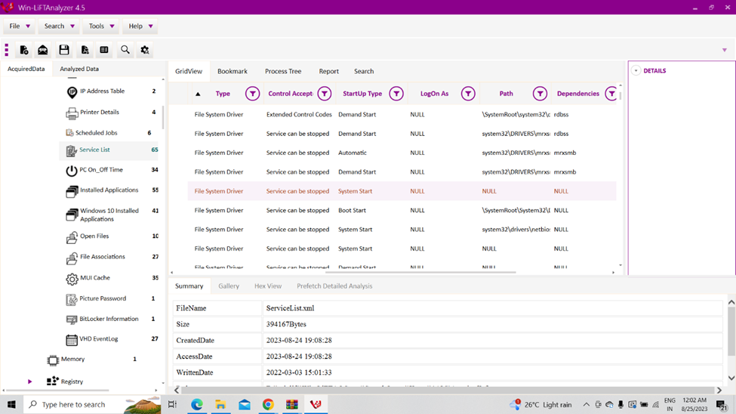

1. **Applications installed in the suspect’s machine:**

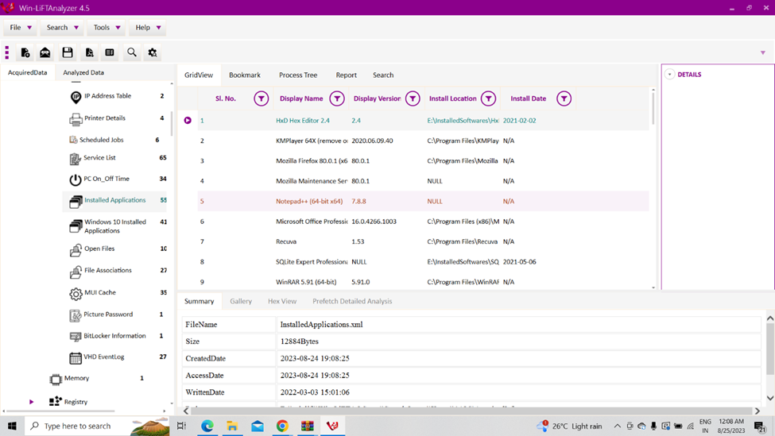

1. **Event Logs:**

**References**

1. **Case, A., & Richard III, G. G. (2005). Investigating RAM Slack and Unallocated Space for Network Intrusion Evidence. Digital Investigation, 2(4), 295-303.**
2. **Carvey, H. (2014). Windows Forensic Analysis Toolkit: Advanced Analysis Techniques for Windows 8 (4th ed.). Syngress.**
3. **Maras, M. H. (2012). Investigating Digital Crime. John Wiley & Sons.**
4. **Sood, A., & Enbody, R. (2013). Targeted Cyber Attacks: Multi-Staged Attacks Driven by Exploits and Malware. Syngress.**
5. **SANS Institute: "Windows Memory Analysis" Link:** <https://www.sans.org/reading-room/whitepapers/forensics/windows-memory-analysis-33403>
6. **Digital Forensics and Incident Response Community: "Memory Forensics" Link:** <https://dfir.community/memory-forensics/>
7. **Computer Forensics World: "Memory Analysis Tools" Link:** <https://www.computerforensicsworld.com/memory_analysis_tools.htm>
8. **BlackHat: "Practical Memory Forensics Analysis" Link:** <https://www.blackhat.com/presentations/bh-usa-07/Nielsen_and_Casey/Presentation/bh-usa-07-nielsen_and_casey.pdf>
9. **RECON: "Physical Memory Analysis for Windows" Link:** <https://www.recon.cx/en/f/reconbrx-w2k6-r0t.pdf>
10. **Digital Corpora: "Memory Images" Link:** <http://www.digitalcorpora.org/corpora/memory/>
11. **Malware Analysis and Incident Response Blog: "Memory Forensics Cheat Sheet" Link:** <https://posts.specterops.io/memory-forensics-cheat-sheet-8b07777e>
12. **"The Art of Memory Forensics: Detecting Malware and Threats in Windows, Linux, and Mac Memory" by Michael Hale Ligh, Andrew Case, Jamie Levy, and AAron Walters**
13. **"Windows Internals, Part 2 (7th Edition)" by Mark E. Russinovich, Alex Ionescu, and David A. Solomon**
14. **WinLift -Memory Analysis Tool:** <https://www.cdac.in/index.aspx?id=product_details&productId=Win-LiFTWindowsBasedLiveForensicsTool>